Project 1 - Applied Statistics: Inference & Modeling (DS 6372)

Summer 2021

Rashmi Patel, David Loveday, Onyeka Emmanuel, Brandon Sucrese

**World Health Organization - Life Expectancy and Advanced Regression**

**Introduction**

The following analysis seeks to identify and describe key factors and interactions which affect life expectancy of residents in 193 countries based upon economic, demographic, immunization and general health data collected by the Global Health Observatory under the World Health Organization for the years 2000 through 2015. Generally, life expectancy has materially improved over this time span across the world and investigations like this, which explore the potential of predictive modeling, may help world leaders to craft policy to address specific remaining deficiencies or bolster programs which show compelling evidence of improvement to the health of their communities.

**Data Description**

The World Health Organization (WHO) data includes a multitude of variables including country, GDP, status, population and the primary variable life expectancy. Several data points across multiple variables were imputed using the MICE function. This data set was collected over the course of the years 2000 to 2015. Data was collected from 193 countries in which 87% of the countries are labeled as developing. Many of these countries such as Yemen and the United States of America are missing significant portions of data in a variety of variables. Data was collected directly from the WHO with the goal of understanding the influences of life expectancy on a global scale. The dataset was delivered as a comma separated value (csv) with 2939 rows and 22 columns. Of the columns, two (Country, Status) were categorical string variables while the others were continuous variables..

**Missing Values & Imputation Discussion**

The World Health Organization data has many interesting characteristics. The first major discovery was the large amount of data missing. Figure 3.1 shows missing data rows by feature. Note that eight of the twenty-three continuous features are not missing any values, seven features are missing less than two percent, five variables are missing between five and fifteen percent, and two features are missing greater than fifteen percent. Incorporation of features with imputed values in excess of fifteen percent is generally not advisable, and while the risks of their inclusion was acknowledged by the project team, the analysis proceeded with caution. These particular variables are discussed in more detail in the discussion of the complex linear model.

Imputing categorical variables can often be quite difficult and, fortunate for the analysis, the two principal categorical variables (Country, Status) are full/complete thus not requiring imputation.

Imputation of the continuous features was performed using Multivariate Imputation by Chained Equations (MICE) via classification and regression trees under the assumption that values were missing completely at random (MCAR). Figure 3.2 shows the co-occurrence of missing values for certain combinations of features and generally supports the MCAR assumption. One potential violation may exist between the Population and GDP which both also happen to have higher missing value rates at twenty-two and fifteen percent respectively. Further inspection of the Pearson correlation coefficient between these two features (-0.028) gives some comfort that there is not a systemic issue with how the data was collected.

Figure 3.3 compares the density plots for each observed factor (blue) against the density of each imputed data (red) for five independent iterations of the MICE imputation routine. Generally, our imputation routine does an excellent job imitating the distribution of our observed data. One notable exception is the BMI feature whose observed distribution appears bimodal and could be perhaps better considered as a categorical variable.

**Initial Independent Feature Exploration & Transform Discussion**

Figure 3.4(a) , Figure 3.4(b) , and Figure 3.4(c) show histograms of all explanatory and response variables in their untransformed (left-most column) and transformed states: cube root (middle-left), log10 (middle-right) and square root (right-most column). Some untransformed variables, like ‘Schooling’ or ‘Total Expenditure’ exhibit normal-distributions, while variables like ‘GDP’ and ‘HIV/AIDS’ are strongly skewed right-tailed or strongly skewed left-tailed like ‘Polio’ of ‘Hepatitis B’. Many of these skewed distributions can be brought to normal or near-normal distributions with transforms (see the log of ‘GDP’ or log of ‘percentage expenditure’) while variables such as ‘Polio’ or ‘Diphtheria’ do not benefit from transforms. Selection of untransformed or transformed permutations of variables was made manually with consideration of their histogram distribution shape and will be discussed in further detail later.

**Correlation between Features**

Figure 3.5 shows a Pearson’s correlation matrix for all combinations of variables and features. In general, most features appear to be weakly correlated to totally uncorrelated but we discuss some exceptions. Starting with our response variable of interest (Life Expectancy), we observe:

· Strong (-0.7) negative correlation with Adult.Mortality

o Also note that Adult.Mortality has moderate correlations with HIV/AIDS (+0.52), income composition of resources (-0.47), and schooling (+0.46)

· Moderate (+0.57) positive correlation with BMI

· Moderate (-0.56) negative correlation with HIV/AIDS

· Strong (+0.73) positive correlation with Income composition of resources

· Strong (+0.75) positive correlation with Schooling

Other exceptionally strong ( > ± 0.6) pair-wise correlations of note include:

· Percentage expenditure & GDP (+0.88)

· Hepatitis B & Diphtheria (+0.62)

· Polio & Diphtheria (+0.67)

· Thinness for 1-19 years & Thinness for 5-9 years (+0.94)

· Income composition of resources & Schooling (+0.81)

· Infant deaths & under five deaths (+1.0)

Most of these strong correlative relationships are intuitive and whose explanation is obvious, for example the perfect correlation between ‘infant deaths’ and ‘under five deaths’, which do not require further investigation. The observation that the variables most strongly correlated with Life Expectancy are also moderately correlated with each other has been noted for further consideration during model construction.

Figures 3.6(a) – 3.6(rr) are a series of scatter plots displaying all combinations of explanatory and response variables while splitting apart those data from ‘Developed’ and those from ‘Developing’ countries and comparing the patterns for the unimputed (missing values removed) against the imputed datasets. Bar charts of the mean value by Country for all years collected for each variable are shown in the series of plots 3.7(a) – 3.7(n).

In line with the observations commented above for the imputation scheme, the plots for the imputed data demonstrate comparable relationships between variables as the unimputed which lends confidence in our imputation procedure.

When analyzing relationships between specific variables, it is immediately obvious that these relationships are often different between ‘Developed’ versus ‘Developing’ countries (captured in the ‘Status’ variable). Figure 3.6(b) which is a simple dot plot showing the range of all Life Expectancy values for the different hints at this as no ‘Developed’ country possesses a value below 70 while ‘Developing’ countries have a minimum below 40. Some examples of extreme divergence of between the two Status values can be seen for ‘Adult Mortality’ vs ‘Life Expectancy’ (Figure 3.6(f)) and ‘HIV/AIDS vs ‘Life Expectancy’ (Figure 3.6(z)), while more subtle, or perhaps no difference, can be seen for ‘Population’ vs ‘Life Expectancy’ (Figure 3.6(d)) or ‘Total Expenditure’ vs ‘Life Expectancy’ (Figure 3.6(w)).

**Simple Linear Regression Model**

To begin understanding this data a simple regression model to predict life expectancy was created. This simple linear regression model allows for a larger audience to understand the model and how to find and develop results. This simple linear regression model may have the benefit of being easily understandable however, it lacks the potential viability from a predictive standard.

The simple linear model used to predict life expectancy includes the explanatory variables GDP, Schooling, and BMI. All predictor variables for this simple linear model were hand selected. To keep the simple model highly interpretable data transformations were not used when selecting these variables. The purpose of this model is to be used as a benchmark to understand the power software brings to model development over human selection.

The original data does not meet the assumptions of linearity, normality and equal variance as in Figure 4.1. The primary assumption that can be seen being broken is normality. Especially within the variable GDP, a transformation to the data will be required to develop a complex linear model that can accurately predict life expectancy. After transformations have been made many of the variables still experience skewness, but using the central limit theorem gives us confidence to move forward. The assumption for independence is critically violated. Data points are collected from the same countries over the course of 15 years. A more complex model such as time series is required for the violation of independence.

In Figure 4.2 the residual plot has a few issues. There appears to be an issue with constant variance within low and high fitted values compared with values found within the middle. There also appears to be a few outliers within the residual plot as well. While the residual plot has few issues, much of the plot is what we would expect from this kind of dataset.

The WHO data set consists of 5 observations with higher Cook’s D larger than the rest of the observations seen in Figure 4.3 and Figure 4.4. Figure 4.3 indicates that most variables either have high residuals or high leverage, however none of the points exhibit both. While the observations with the largest Cook’s D are from smaller countries such as Bosnia, they are still reflective of the larger population and will remain within the dataset.

The parameters, GDP, schooling and BMI to predict life expectancy, produce the linear model; Life Expectancy = 4.5 + 0.00009499(GDP) + 1.628(Schooling) + 0.1005(BMI). GDP, schooling and BMI all have a positive correlation with life expectancy. We would expect life expectancy to find an increase of 0.00009499 for a unit in GDP, 1.628 increase for a unit in schooling and 0.1005 for a unit in BMI. This linear equation produces an Adjusted R-Square of 0.6152.

While this simple linear model is highly intpretable for a larger audience, a more complex linear model or nonparametric model will lead to better performances to match the complexities of the World Health Organization dataset.

**Complex Regression and Nonparametric Models**

The World Health Organization dataset is complex, which makes using a simple linear regression model less than ideal. While a simple linear regression model is easy to interpret, it lacks the dynamics in comparison to more complex linear models or nonparametric models. As discussed above many of the variables have skewness and lack consistent variance. A more complex model, incorporating transformed variables, is better suited to compensate for these issues.

To add complexity to the linear model while getting better results, several approaches were taken. First we attempted to get a model using forward selection but it did not perform well. So we created a loop that ran a simple linear model while removing a variable from the model before each run and storing the RMSE and features removed for each run in a dataframe (Figure 4.5). We then filtered for rows where the RMSE reduced after removing a feature as that would mean that feature is not important to our model. We then manually removed these features one by one to see how the RMSE on the test data is affected, keeping features that caused the RMSE to increase when removed from the model.

We then used a loop to run glmnet for alpha 0 to 1 in increments of 0.1, using the MSE to find the top influential Variables (Figure 4.6). The RMSE for the training set and Test set were pretty close (1.82 and 2.07 respectively) so that was good. With a list of these features and their influence on the model, we began manually adding and removing features till we got the lowest RMSE with the predictions of our test set to further build our complex model.

Finally, we did a correlation test to see which variables are most significantly correlated to the response variable which in this case is Life expectancy (Figure 4.7). We used those variables, trying different interaction terms and seeing how it affected the RMSE for the test set. Thus we were able to get our complex model (Figure 4.8)

A third modeling approach was employed which utilized a random forest model using all the explanatory variables and the log transformed response variable. The random forest approach utilized the comparison of many uncorrelated models (the individual “trees”) and picks the average of the outputs of all trees to deliver a “forest”. The underlying logic is that though individual trees may produce significant errors, the overall outcome will improve as the majority of the group will have low errors. These models tend to yield strong predictive power but can be very difficult to interpret.

The table below comparisons the performance of the simple regression model, complex regression model and the non-parametric random forest model:

|  |  |  |
| --- | --- | --- |
| Model | Adjusted R-Squared | MSE |
| Simple Linear Regression | 0.6152 | 34.83072 |
| Complex Linear Regression | 0.896860 | 3.416438 |
| Non-parametric | 0.9639 | 3.114853 |

The nonparametric and complex linear regression models both have similar MSE’s while the simple linear regression severely underperforms

**Summary**

Testing indicates that better performing models are possible with increasing complexity, including transformed variables, but quickly lose any realistic interpretation power. The nonparametric Random Forest model yielded the strongest predictive performance of the three, while the model selected by pure intuition performed the weakest. When considering the formal goals of this analysis, namely actionable insights for world leaders, interpretability may be more coveted than pure predictive power. Further, simplicity is paramount as the anticipated audience will be non-technical. The preceding analysis demonstrates that life expectancy can effectively be predicted by these given explanatory variables and additional background study of the source and collection method of each variable could provide guidance on what level of complexity would be appropriate for a ‘final’ model.

These complex models derived from these data can not transfer to some broader population and retain validity as we know virtually nothing about the data collection process, nor genesis of each row. The analysis proceeded under the assumption that the data provided is accurate, however, some variables are missing a significant number of values which presents a serious challenge. These missing data values were imputed using a MICE routine incorporating categorical and regression algorithms. A simple multiple linear regression model was built, where the selection of untransformed variables was guided only by intuition. A more complex multiple linear regression model was constructed, which considered transformed variables and potential interactions, which leveraged a LASSO variables selection. Finally, a random forest model was developed to test the upper limits of potential predictive power.

**Appendix**

Code: <https://github.com/RashmiAPatel19/SMU-6372-Applied-Stats/tree/main/Project1>

Figure 3.1

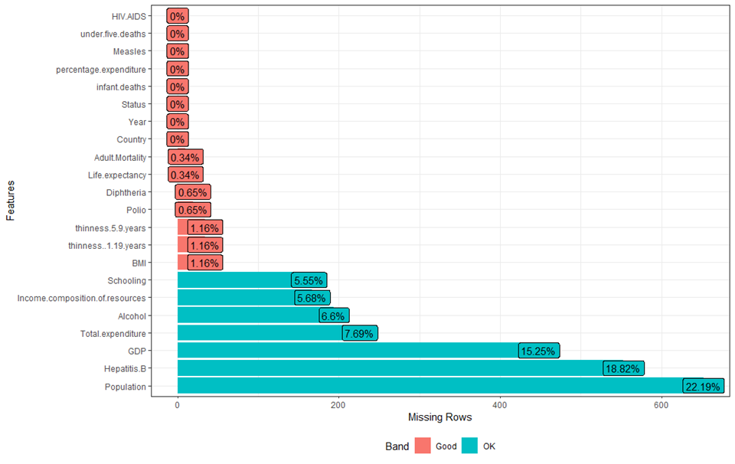

Figure 3.2

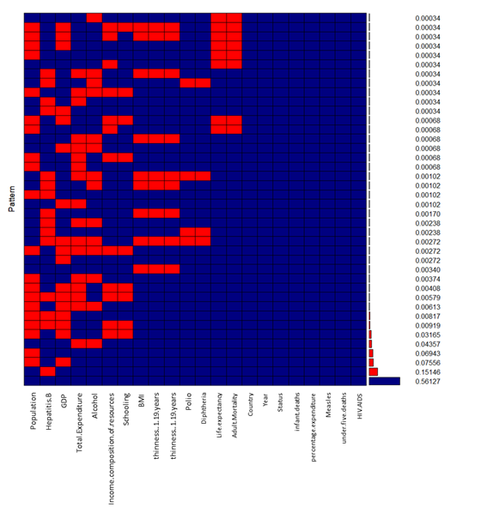

Figure 3.3

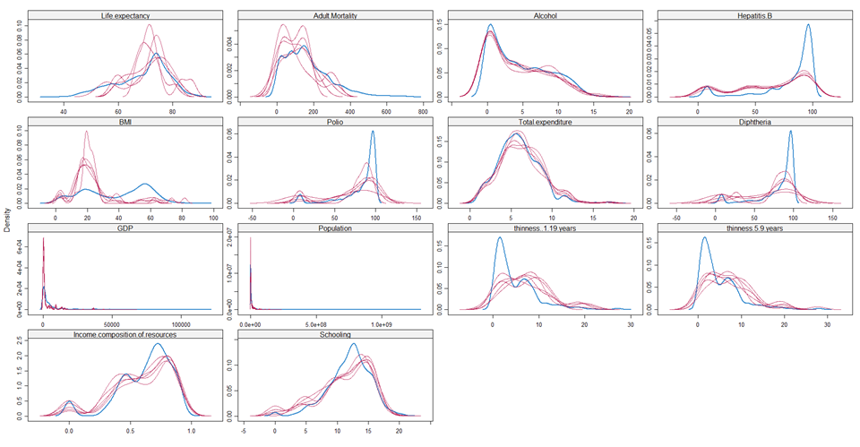

Figure 3.4(a)

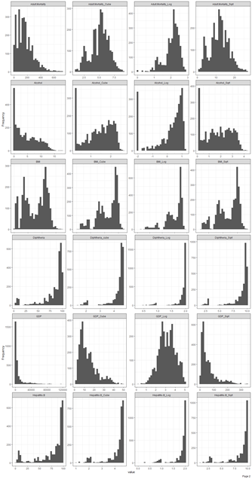

Figure 3.4(b)

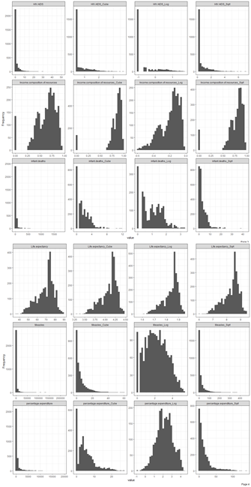

Figure 3.4(c)

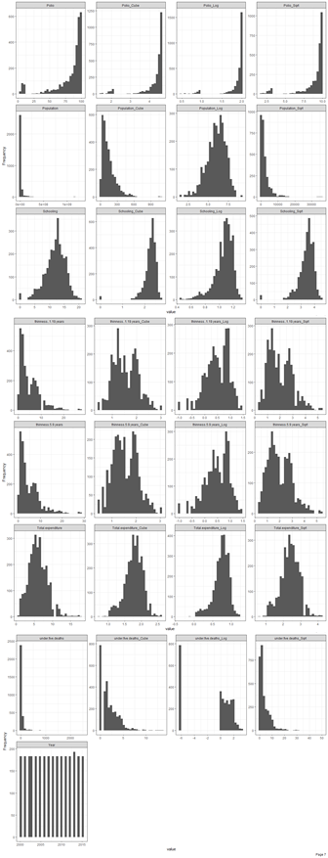

Figure 3.5

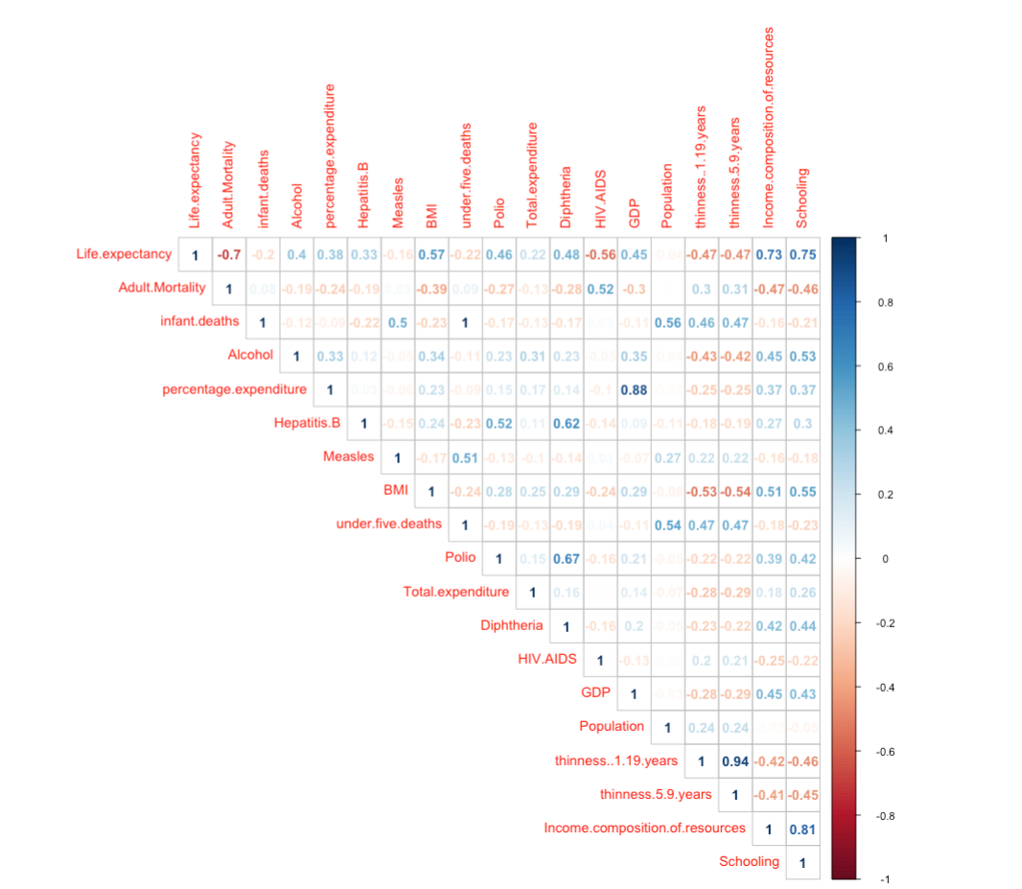

Figure 3.6(a)

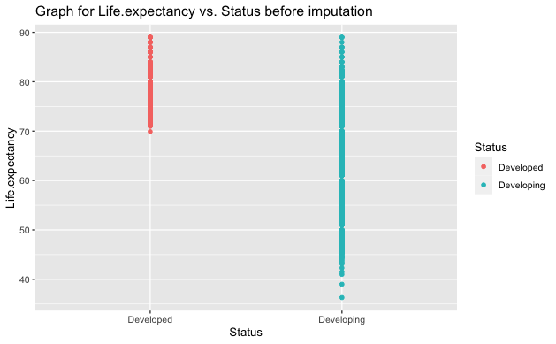

Figure 3.6(b)

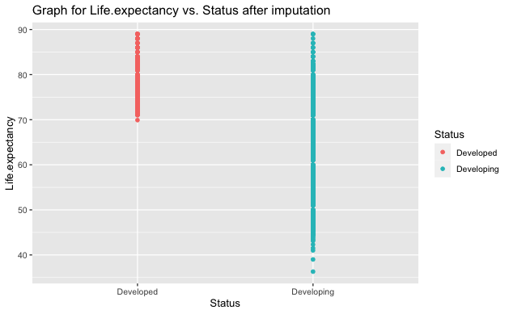

Figure 3.6(c)

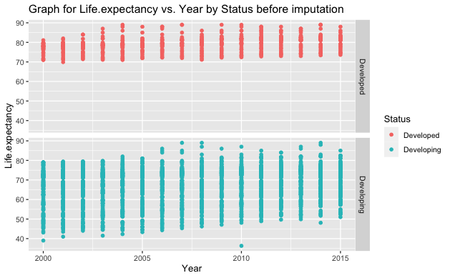

Figure 3.6(d)

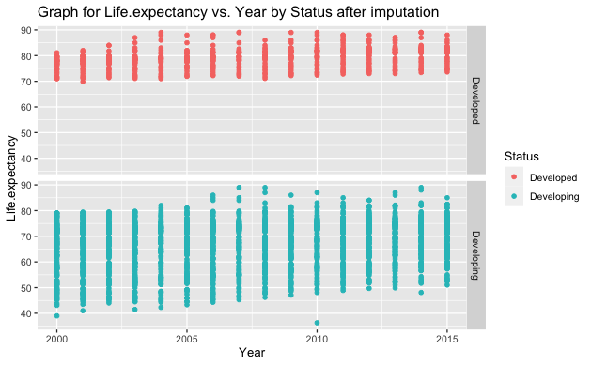

Figure 3.6(e)

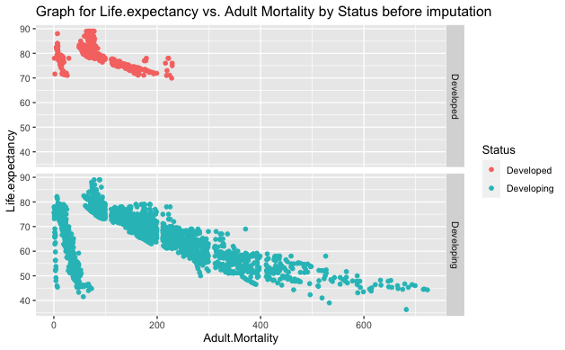

Figure 3.6(f)

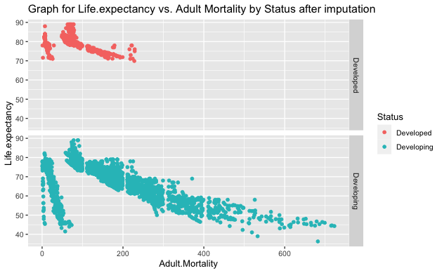

Figure 3.6(g)

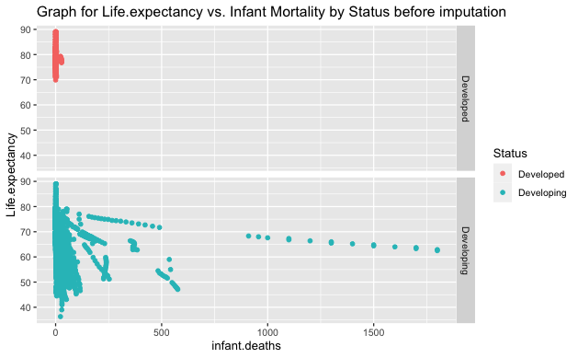

Figure 3.6(h)

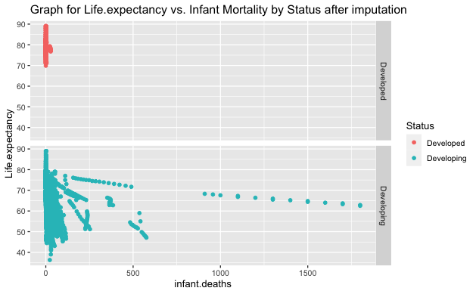

Figure 3.6(i)

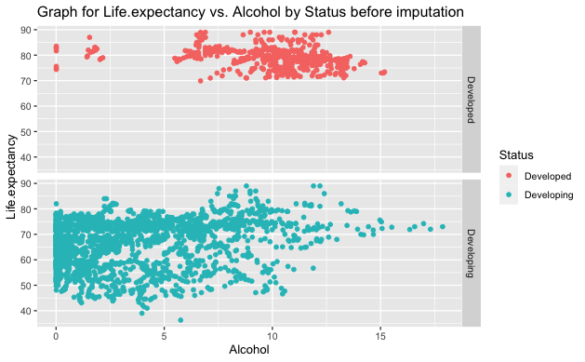

Figure 3.6(j)

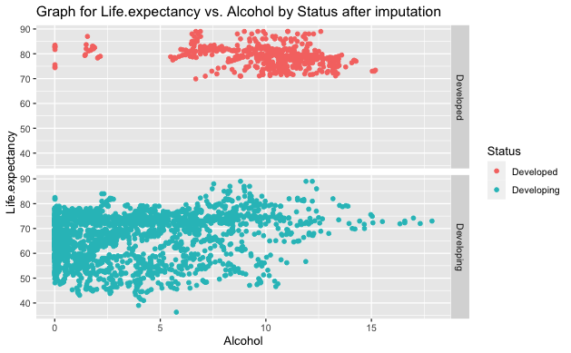

Figure 3.6(k)

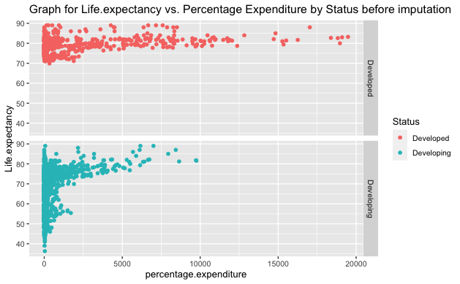

Figure 3.6(l)

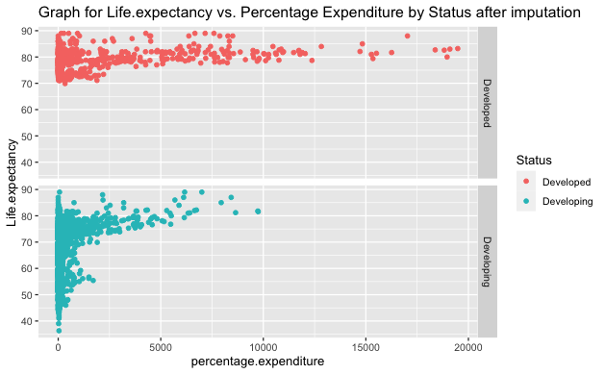

Figure 3.6(m)

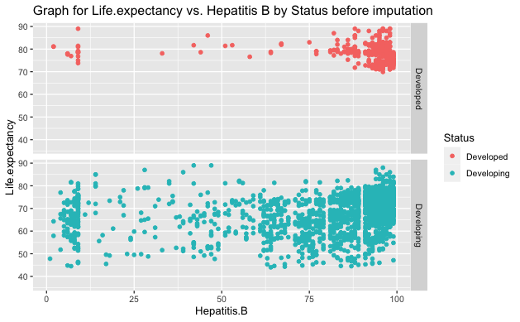

Figure 3.6(n)

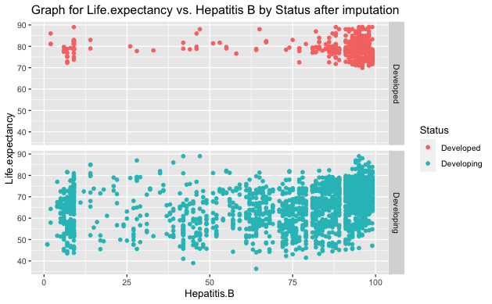

Figure 3.6(o)

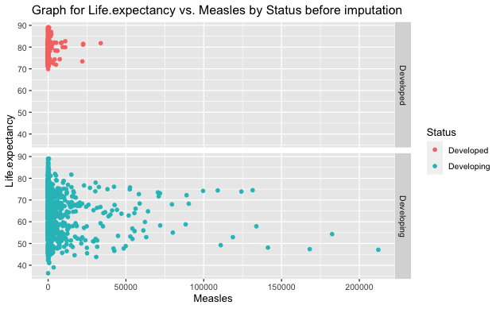

Figure 3.6(p)

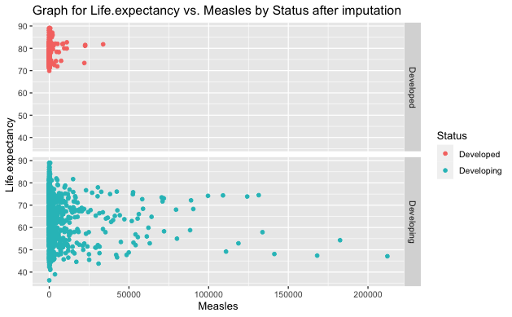

Figure 3.6(q)

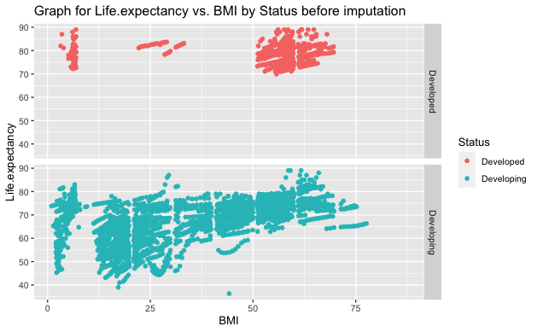

Figure 3.6(r)

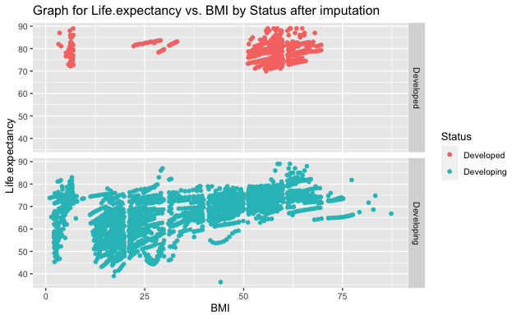

Figure 3.6(s)

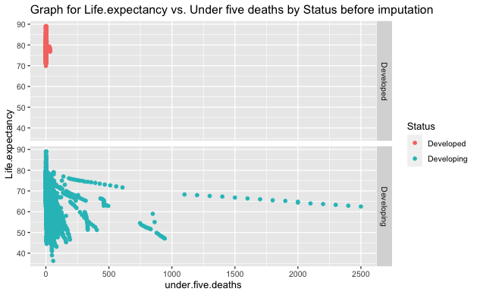

Figure 3.6(t)

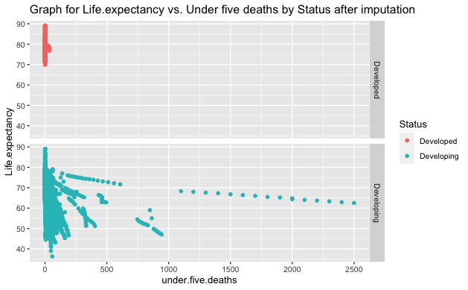

Figure 3.6(u)

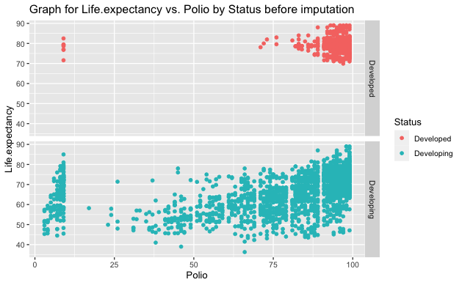

Figure 3.6(v)

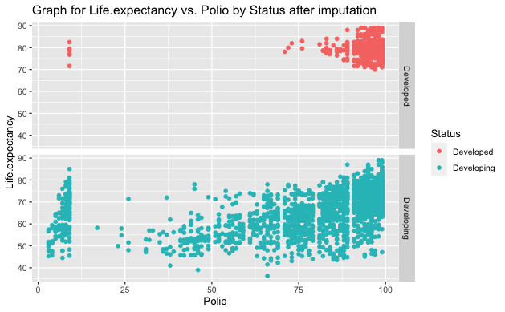

Figure 3.6(w)

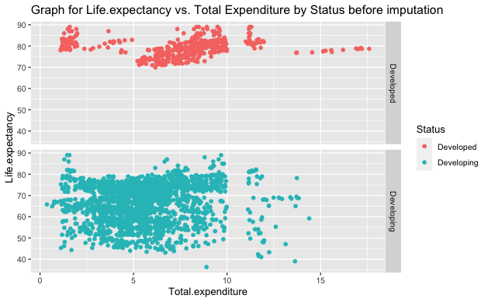

Figure 3.6(w)

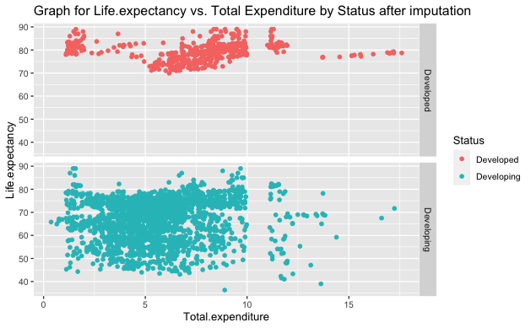

Figure 3.6(x)

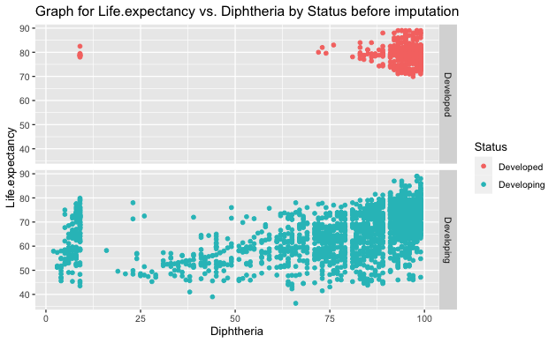

Figure 3.6(x)

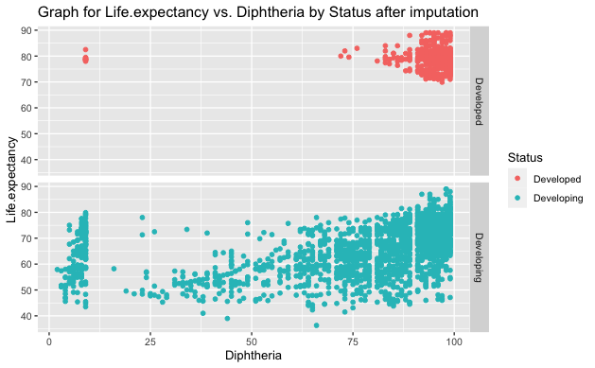

Figure 3.6(y)

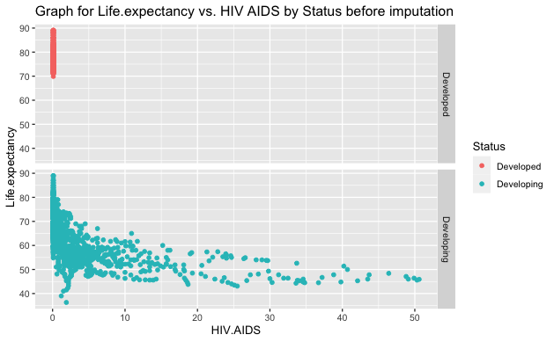

Figure 3.6(z)

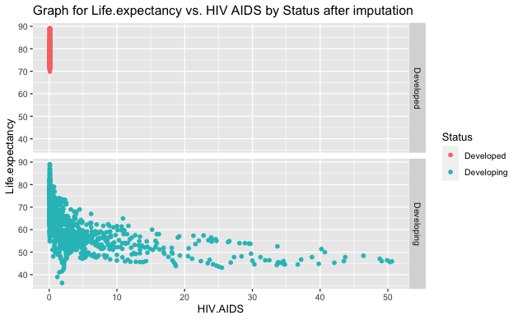

Figure 3.6(aa)

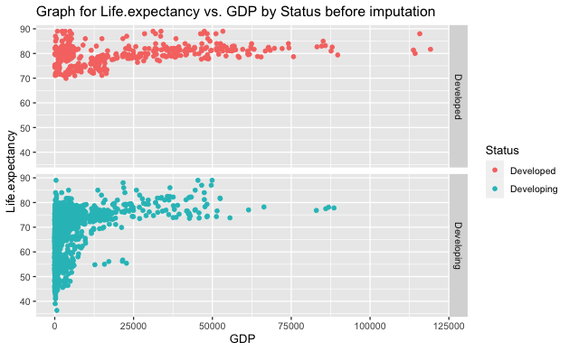

Figure 3.6(bb)

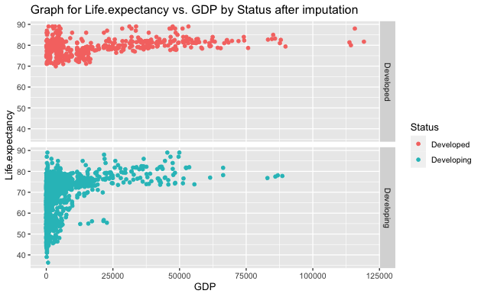

Figure 3.6(cc)

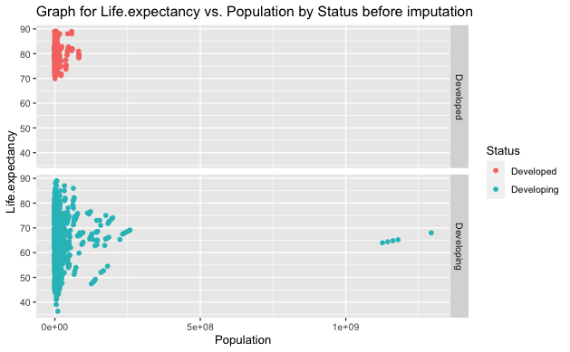

Figure 3.6(dd)

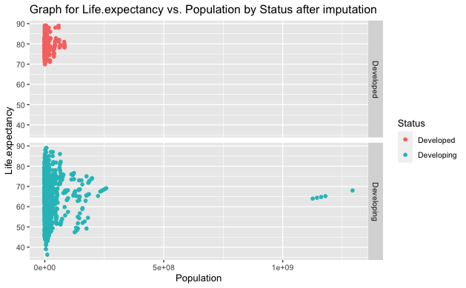

Figure 3.6(ee)

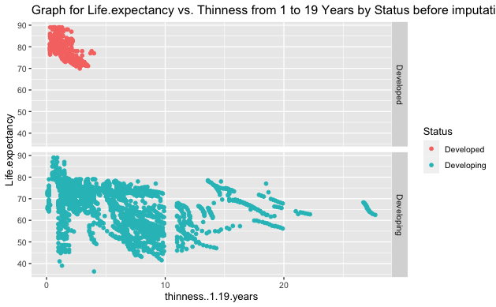

Figure 3.6(ff)

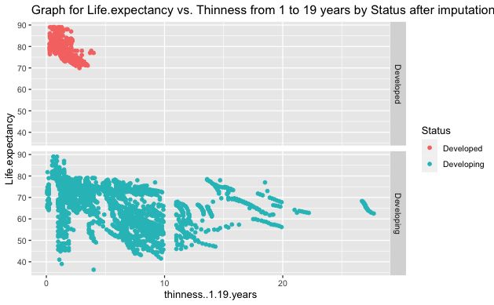

Figure 3.6(gg)

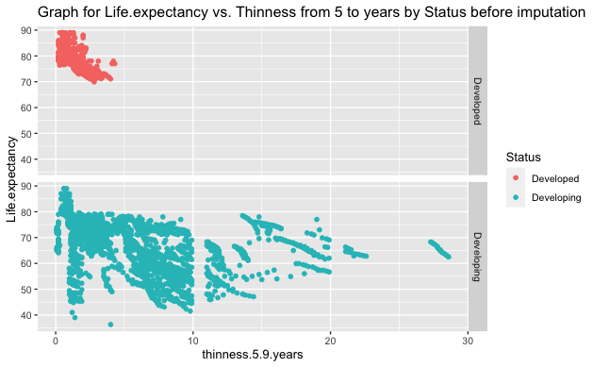

Figure 3.6(hh)

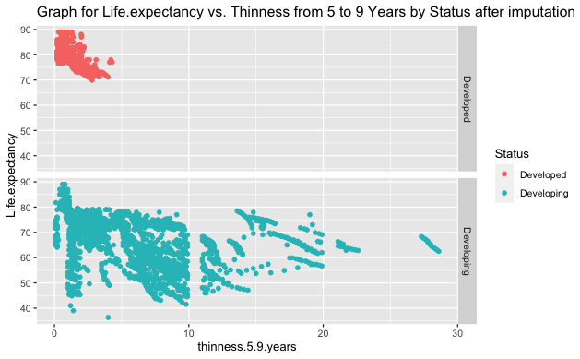

Figure 3.6(ii)

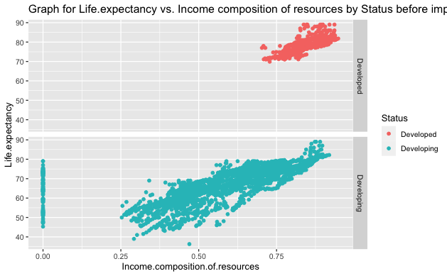

Figure 3.6(jj)

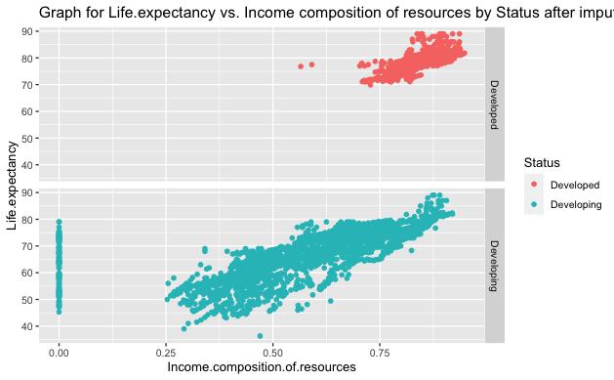

Figure 3.6(kk)

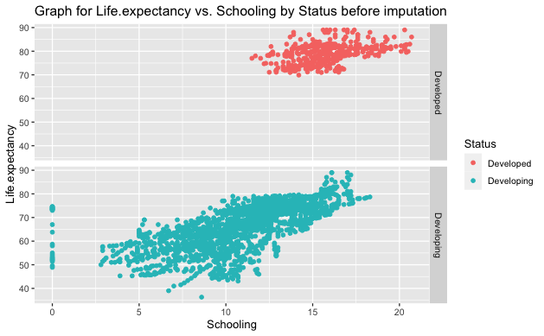

Figure 3.6(ll)

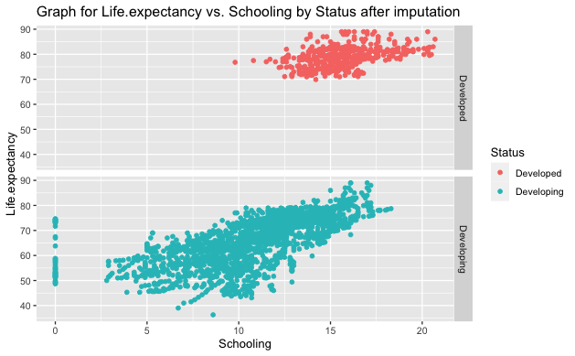

Figure 3.6(mm)

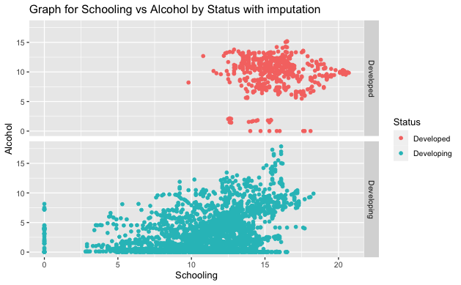

Figure 3.6(nn)

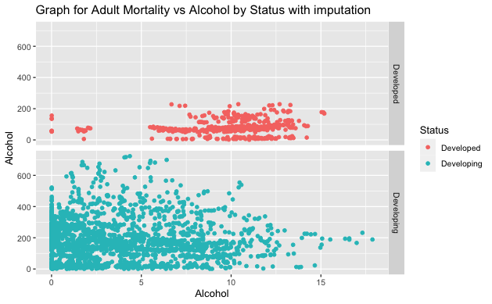

Figure 3.6(oo)

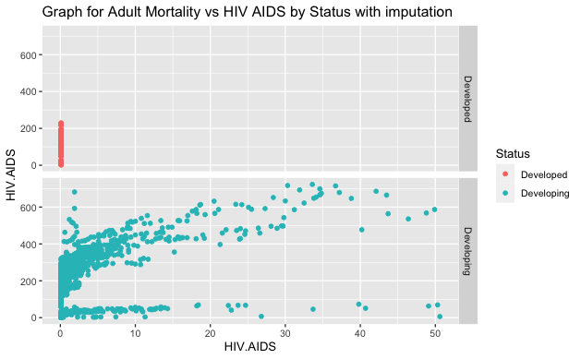

Figure 3.6(pp)

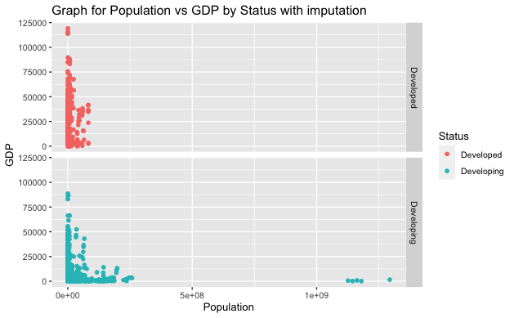

Figure 3.6(qq)

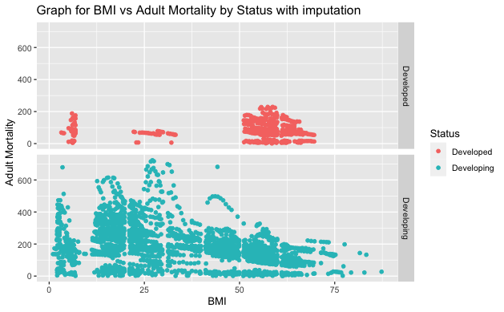

Figure 3.6(rr)

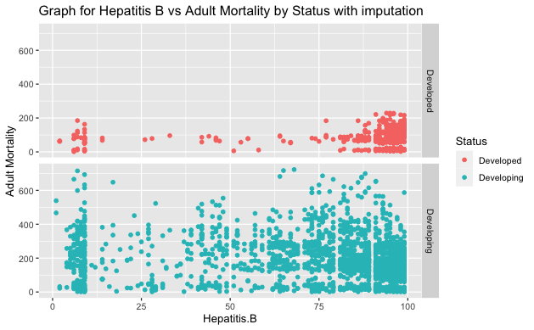

Figure 3.7(a)

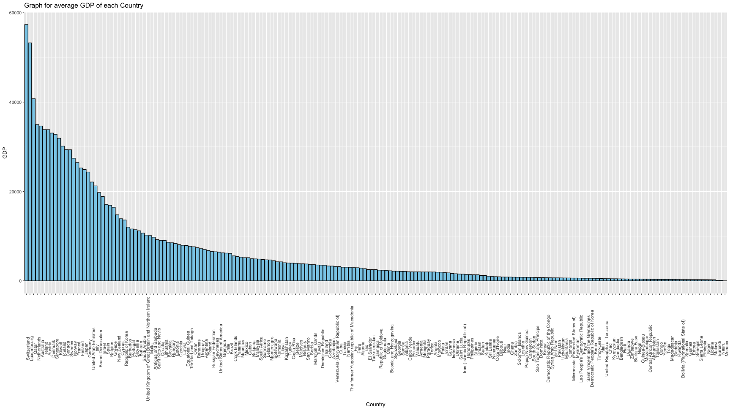

Figure 3.7(b)

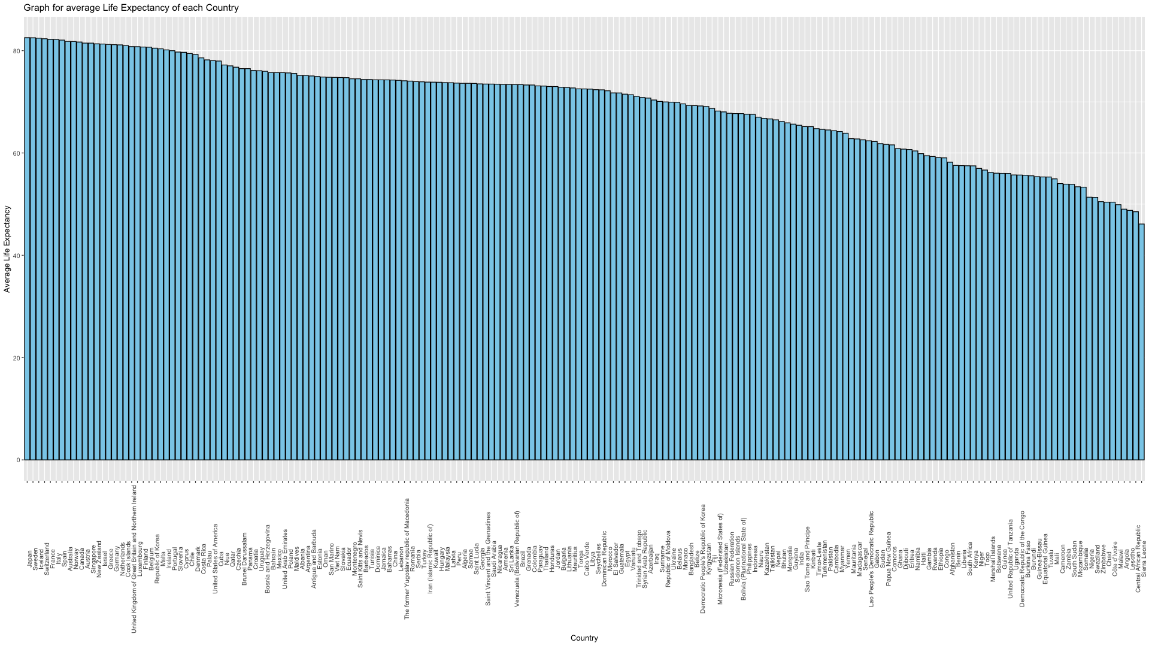

Figure 3.7(c)

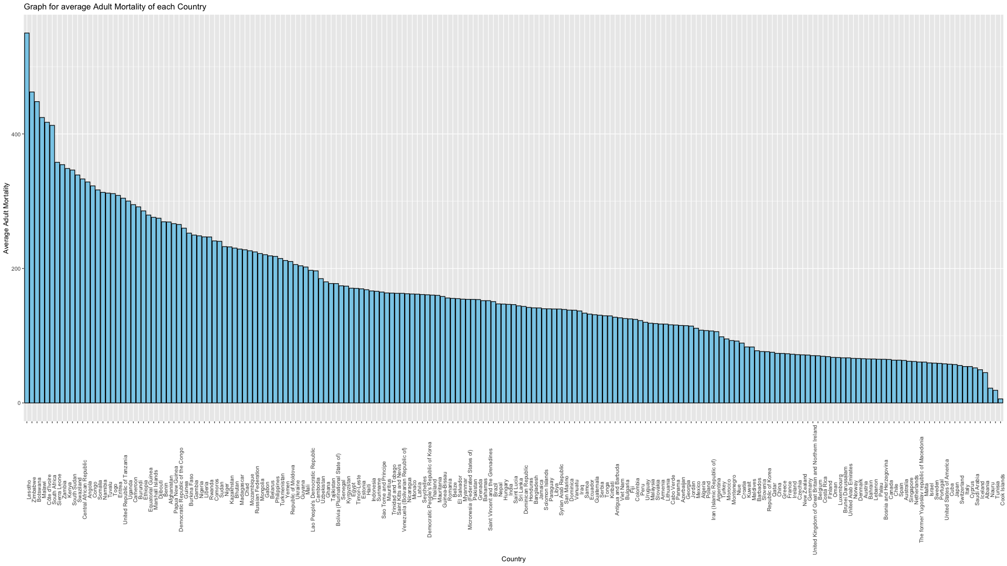

Figure 3.7(d)

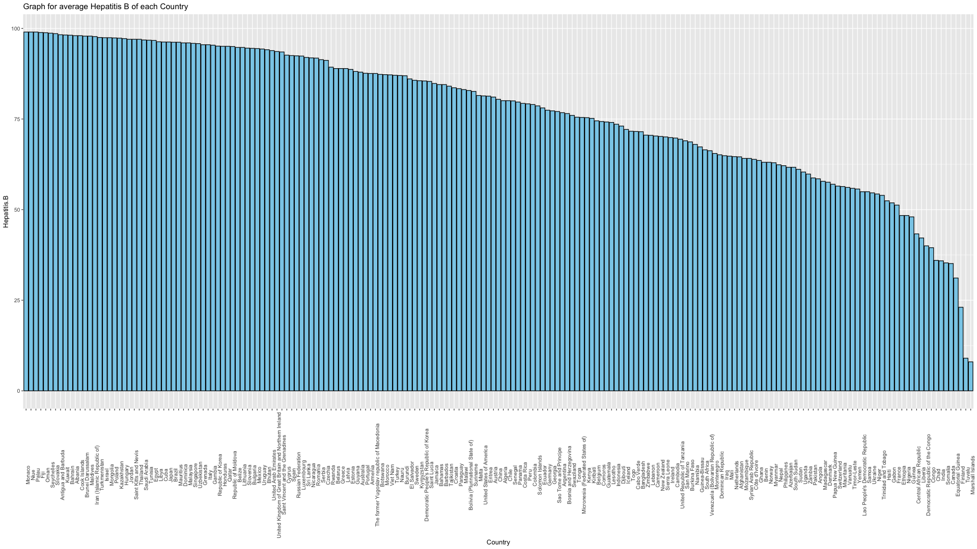

Figure 3.7(e)

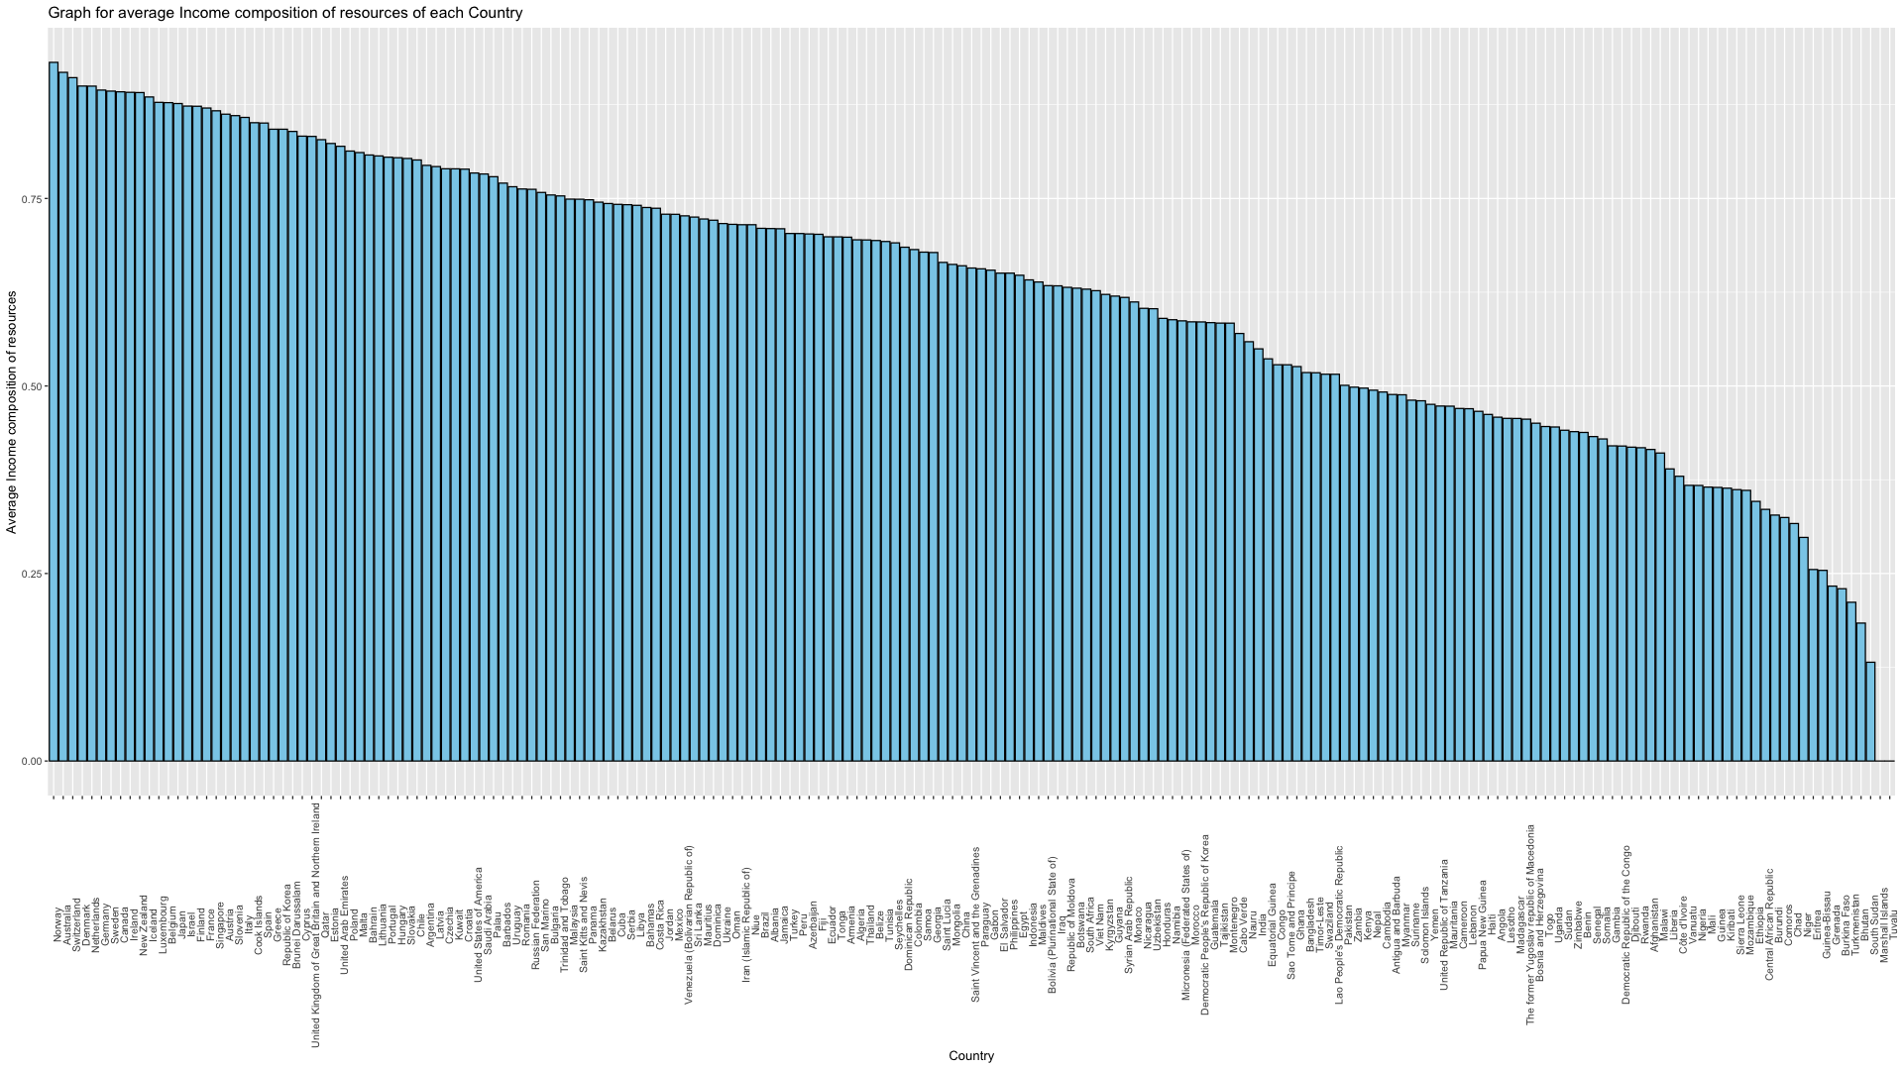

Figure 3.7(f)

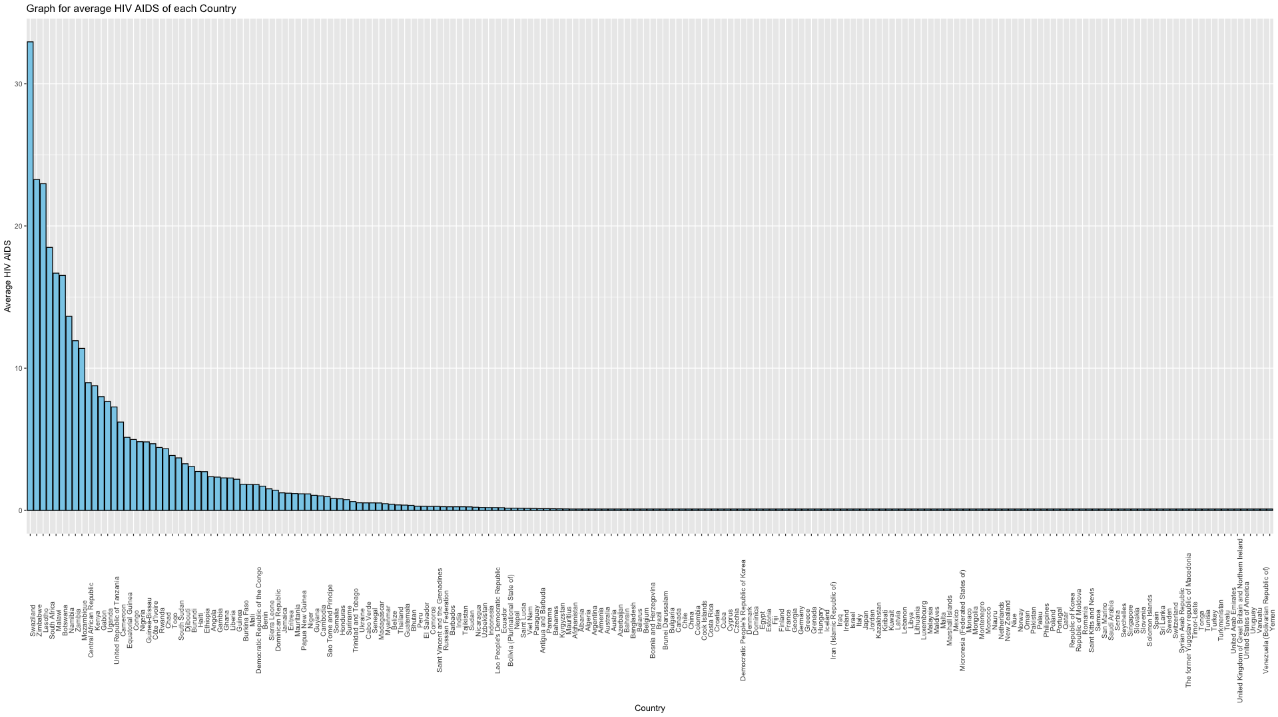

Figure 3.7(g)

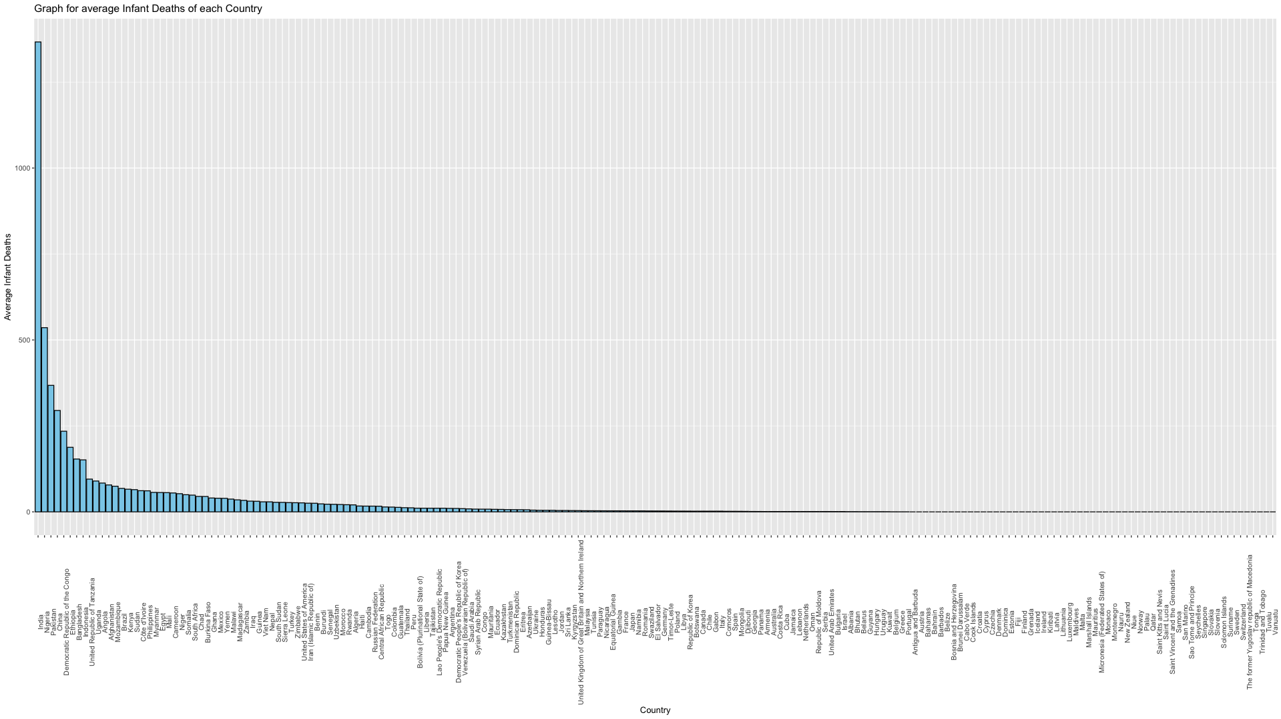

Figure 3.7(h)

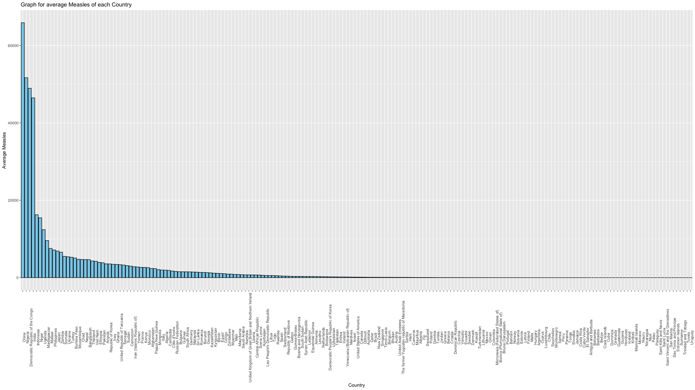

Figure 3.7(i)

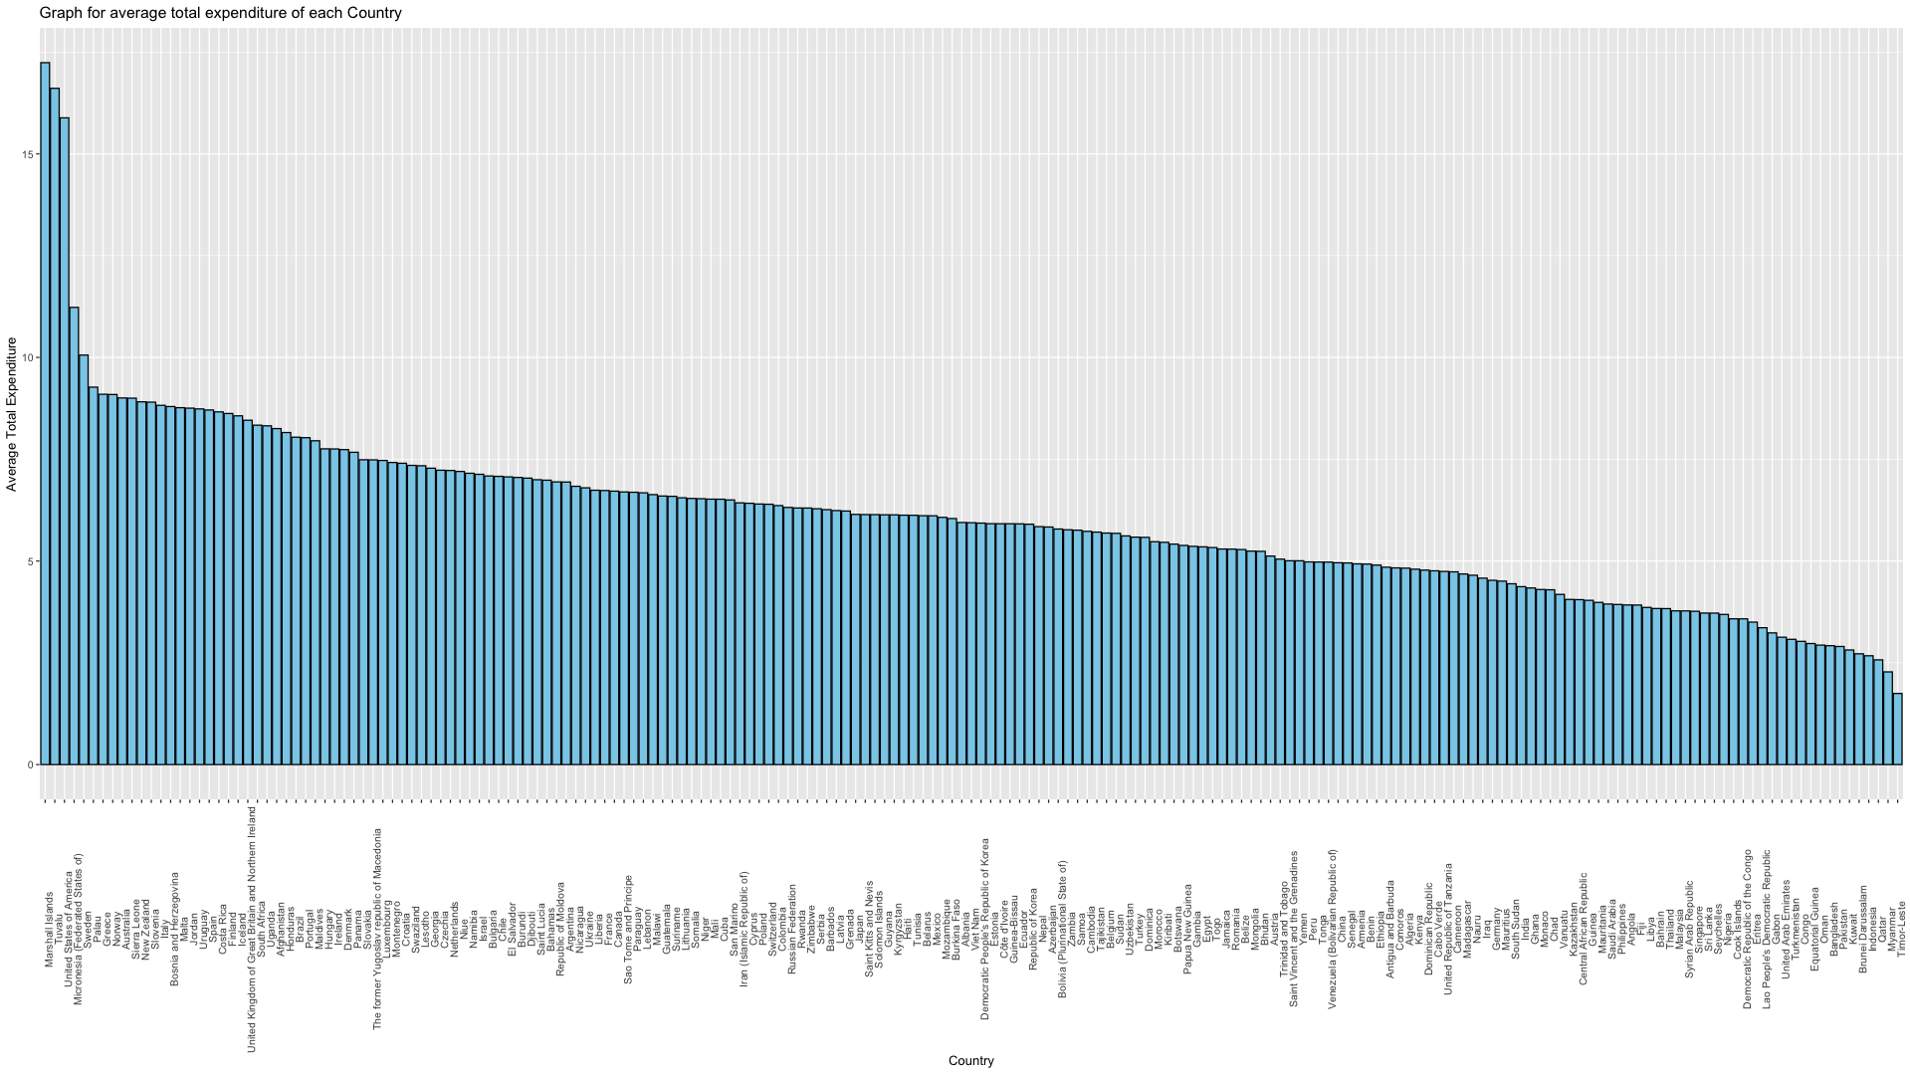

Figure 3.7(j)

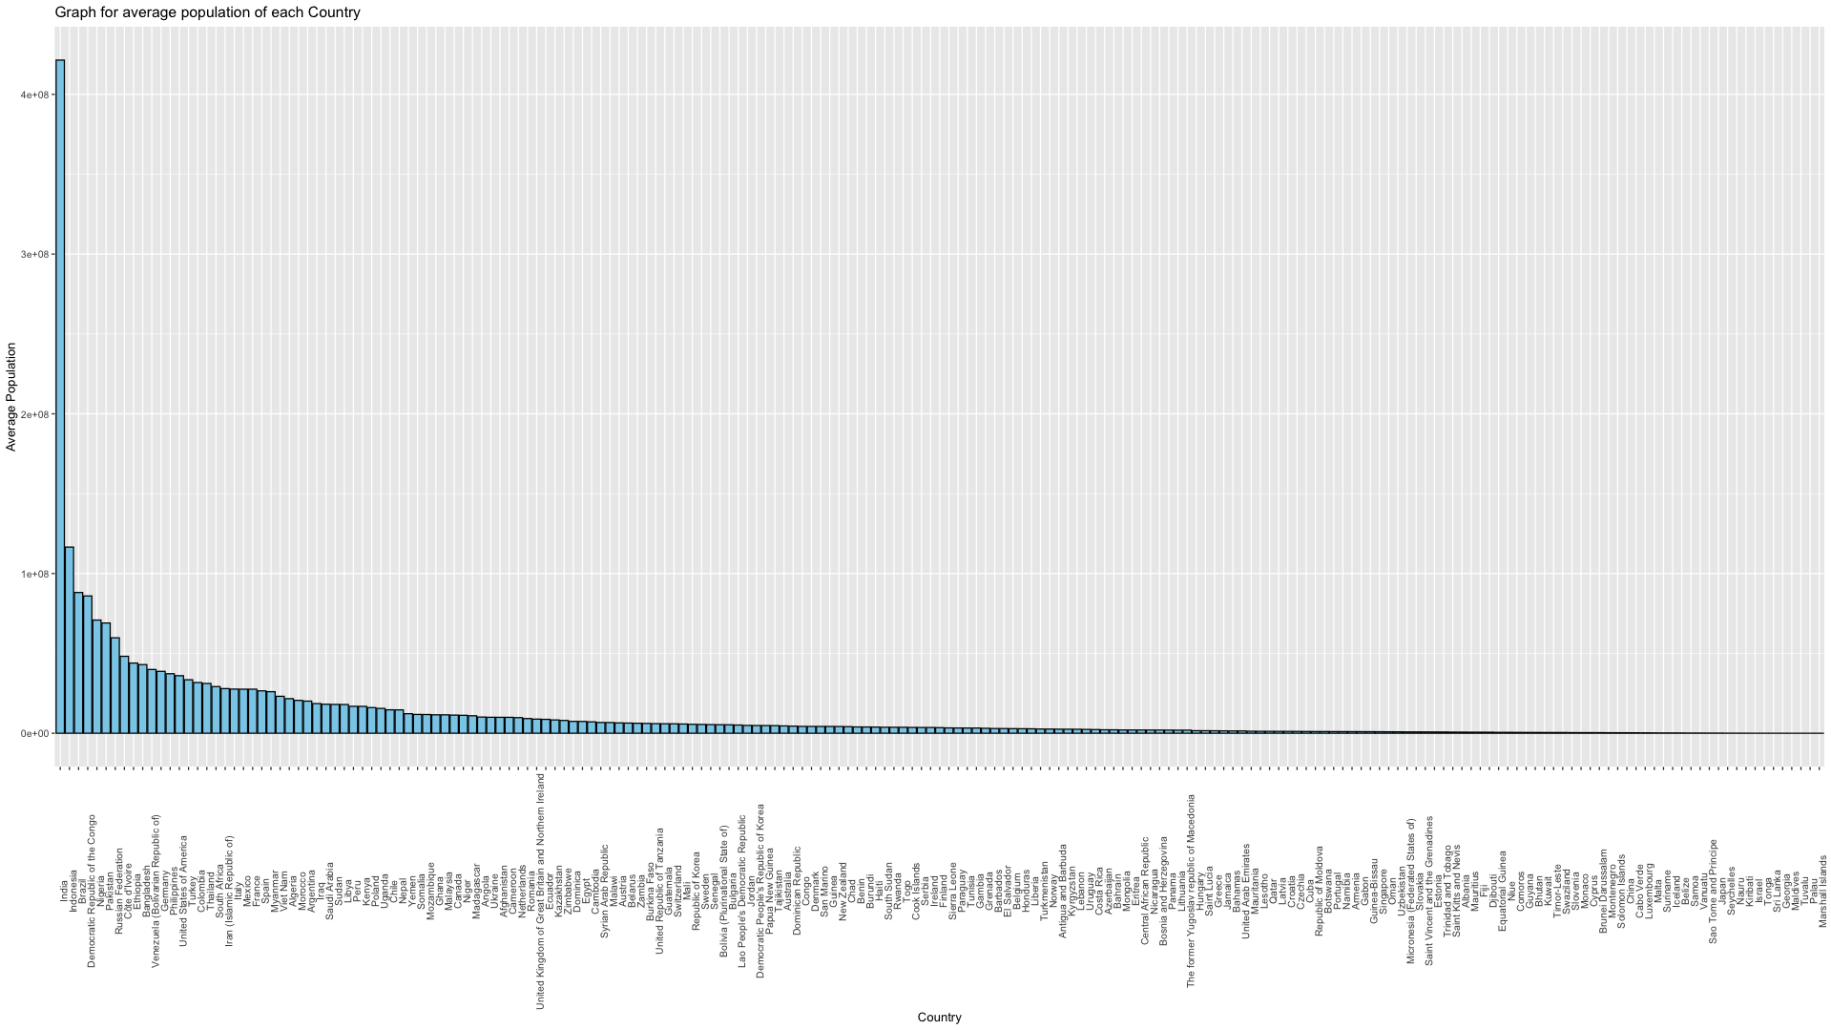

Figure 3.7(k)

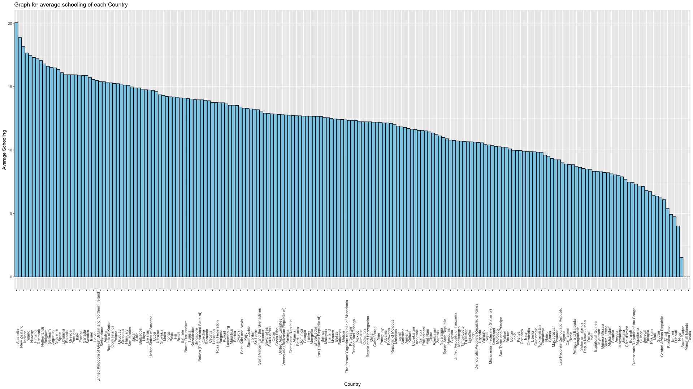

Figure 3.7(l)

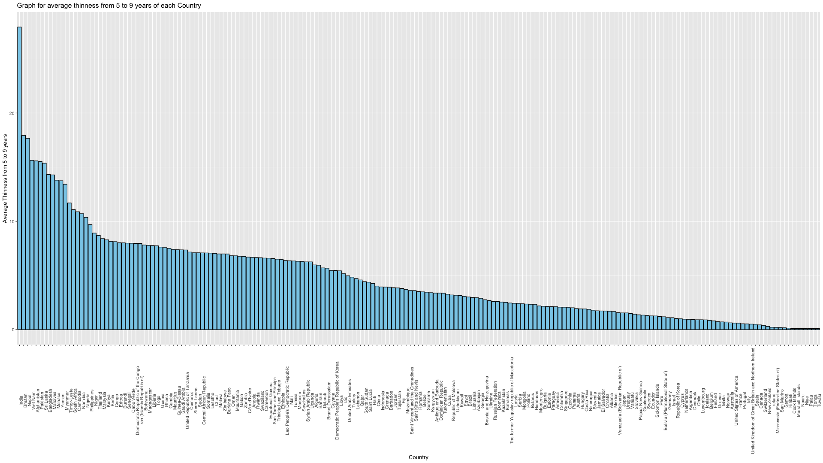

Figure 3.7(m)

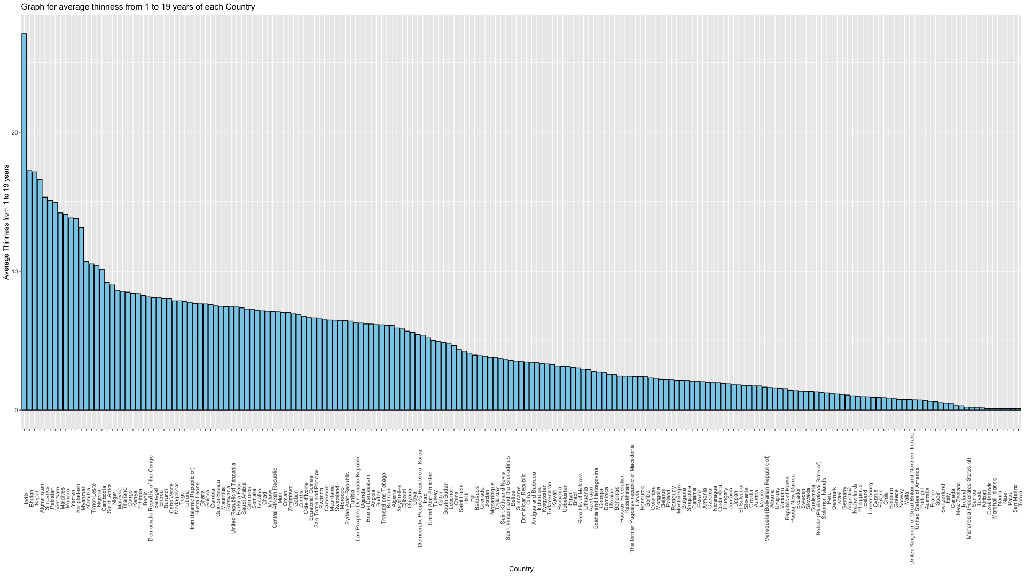

Figure 3.7(n)

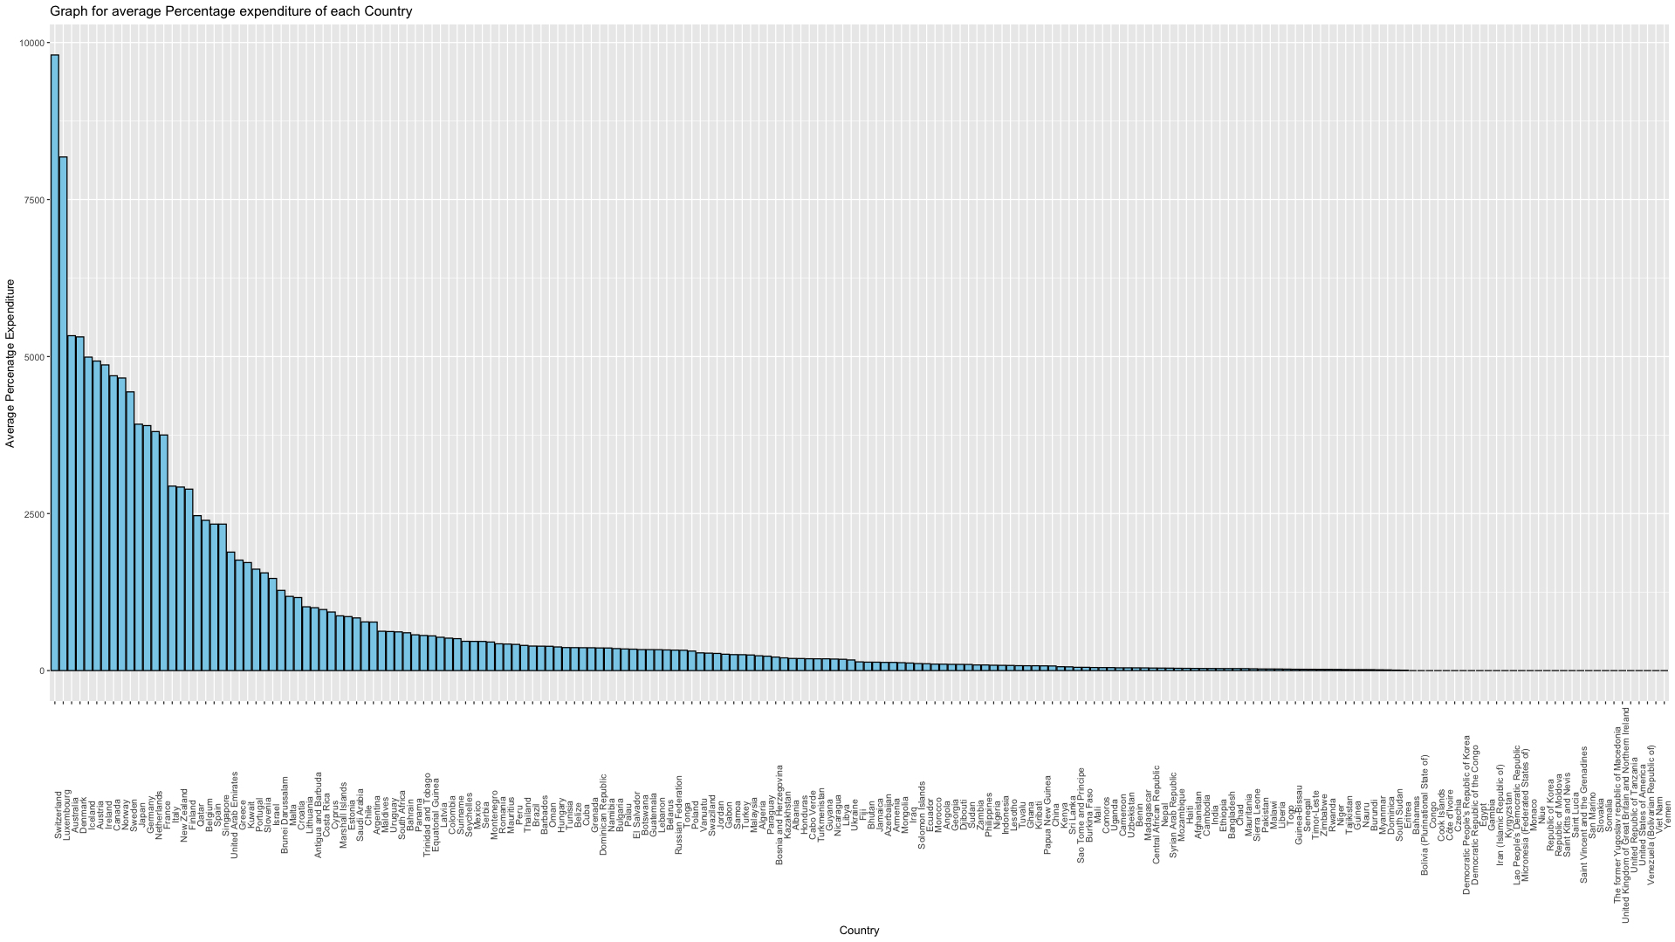

Figure 4.1

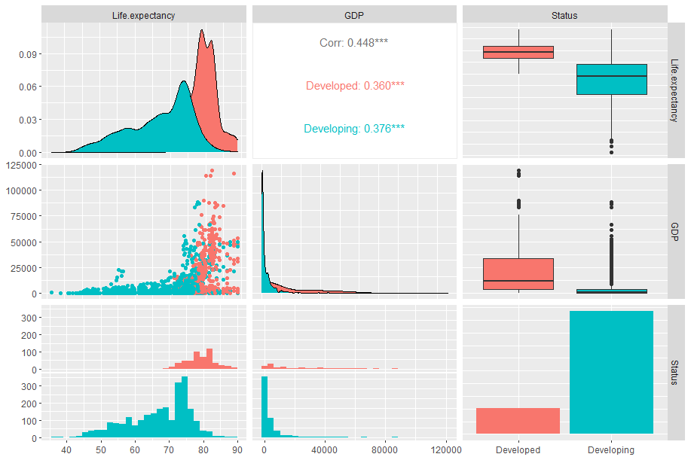Ffi

Figure 4.2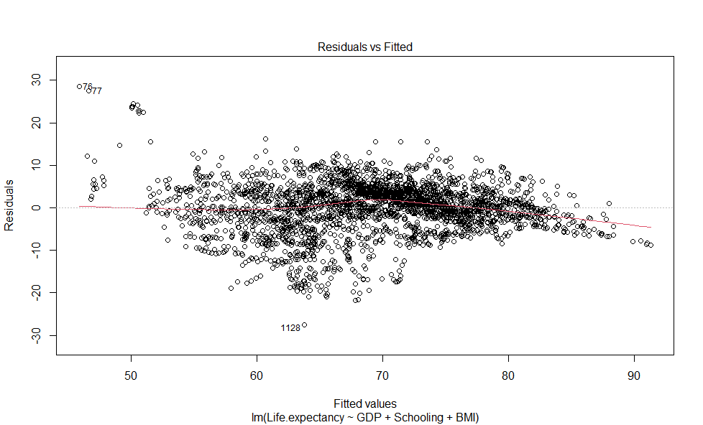F

Figure 4.3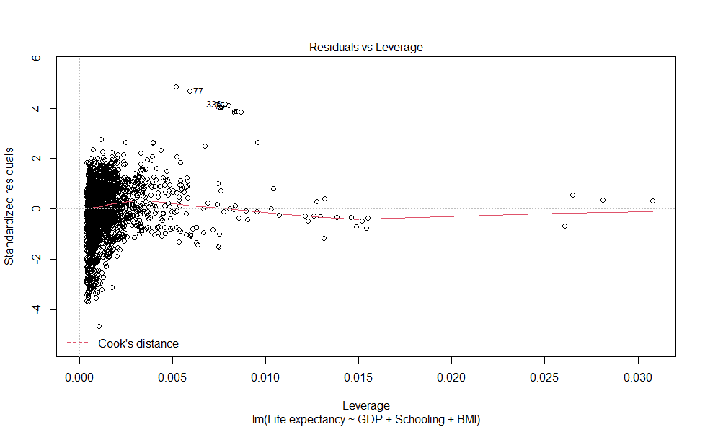

Figure 4.4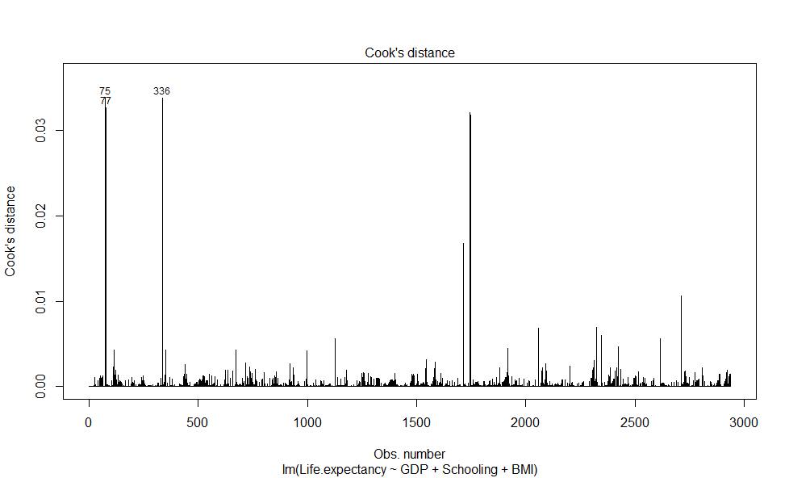

Figure 4.5

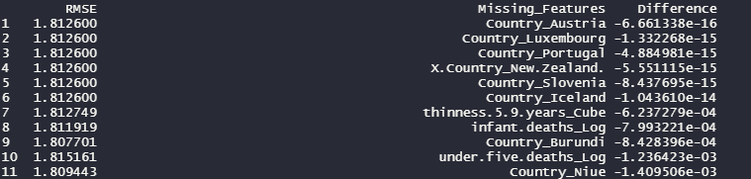

Figure 4.6

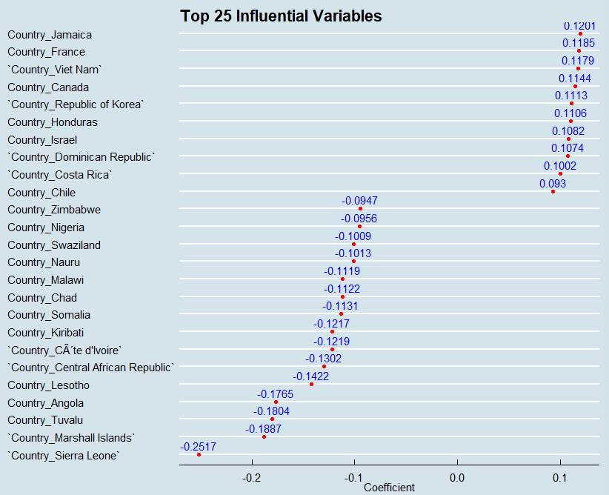

Figure 4.7

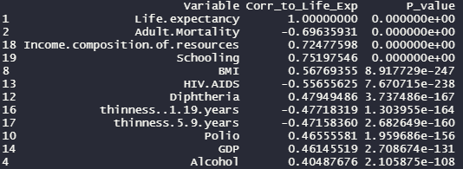

Figure 4.8.1 (Complex Model)

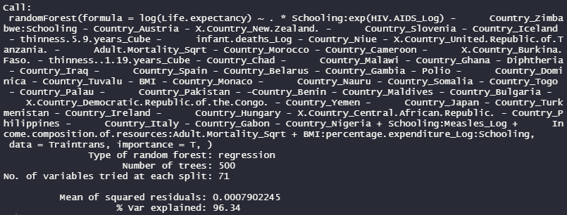

Figure 4.8.2

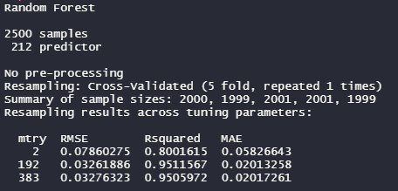

Figure 4.8.3

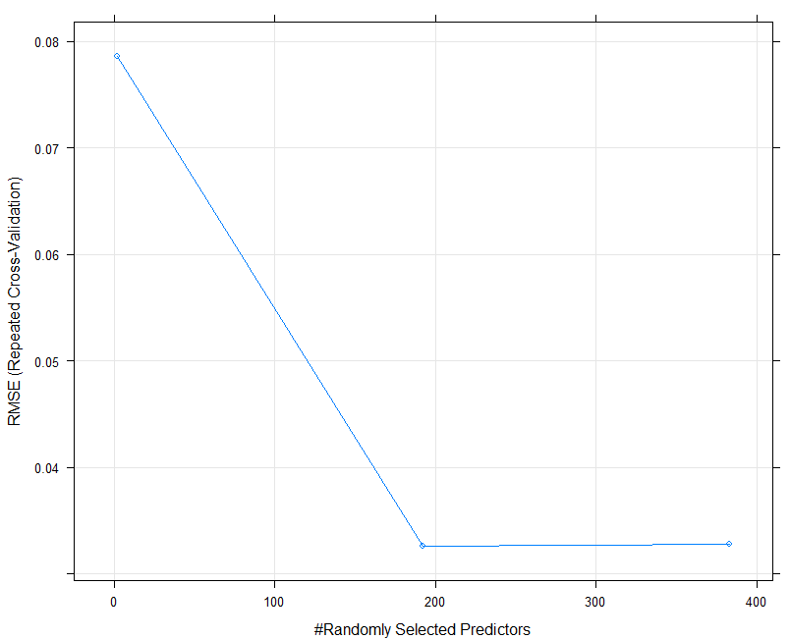

Figure 4.8.4

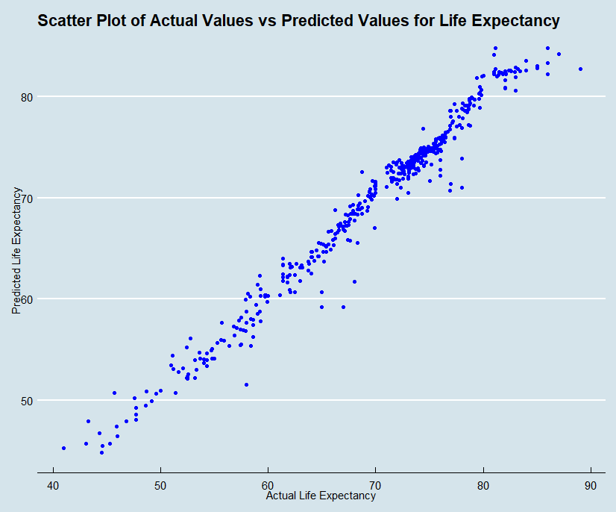

Figure 4.8.5 (Red is Predicted, Blue is Actual)

